BBB Awards 2007 Manship

Torch Award for Ethics in Business

Last night the Better Business Bureau of South Central Louisiana honored four businesses with the 2007 Douglas Manship, Sr. Torch Award for Ethics in Business at its 57th Annual dinner & Torch Award Banquet. Recognized were:

Gary Johnson & Associates, Inc.
Gage Telephone Systems, Inc.
Kleinpeter Farms Dairy
The Shaw Group Inc.

Held at the Holiday Inn Select, the event was emceed by WBRZ’s Whitney Vann. The evening’s featured speaker, legendary LSU men’s basketball coach, Dale Brown, made an impassioned plea for ethics in business, as well as in the personal lives, of Louisiana citizens. He and the honorees told the BBB members that while ethical behavior is not always easy, it is the right thing to do in all situations.

The BBB has promoted ethical business practices for 57 years in Baton Rouge and the 11 surrounding parishes of South Central Louisiana. For assistance in verifying the reliability of businesses or charities, making a complaint against a business, pursuing automotive problems through the BBB’s national AutoLine program or for advice, visit the BBB website at www.batonrouge.bbb.org.

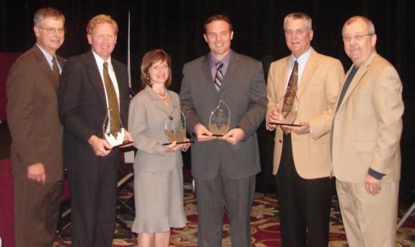
Pictured are BBB Board Chairman Steve Lousteau, Capital One; Jeff Kleinpeter, Kleinpeter Farms Dairy; Kerry David, The Shaw Group Inc.; Greg Wood, Jr., Gage Telephone Systems, Inc.; Gary Johnson, Gary Johnson & Associates, Inc.; and BBB President Jim Stalls.

